**Lab 4**

Jiho Kim, Garth Slaney

ENSF 480 | Principles of Software Design

Submission Date: October 16, 2020

University of Calgary

**Exercise A**

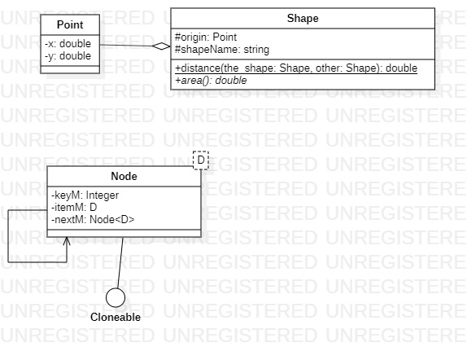

**Exercise B**

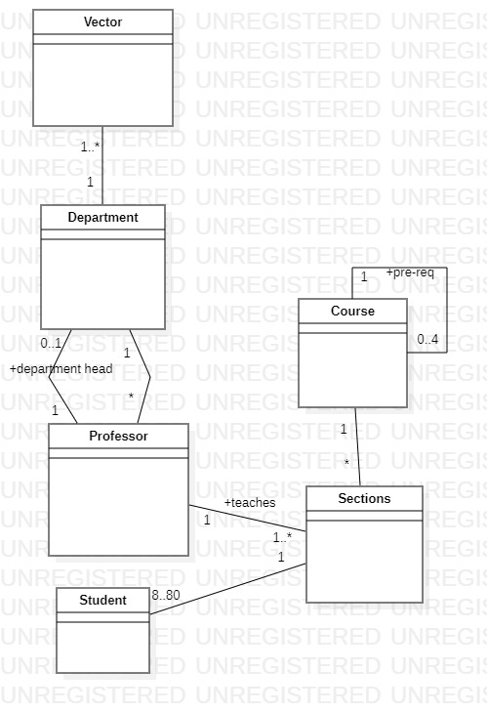

**Exercise D**

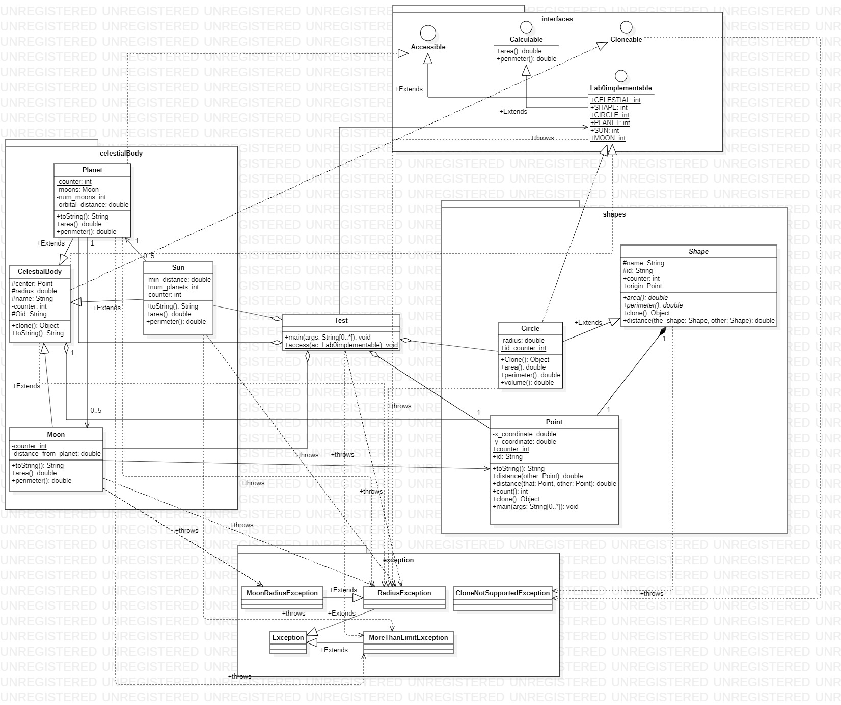

**Exercise E**

